
MATHS METHODS 3 & 4
TRIAL EXAMINATION 2
SOLUTIONS
2007

- D 9. D 17. B
- B 10. C 18. C
- C 11. E 19. C
- C 12. B 20. E
- D 13. D 21. D
- B 14. A 22. E
7. E 15. A
8. A 16. E

Section 1 – Multiple-choice solutions

Question 1

For 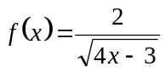, the maximal domain is given by
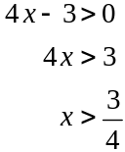
The answer is D.

Question 2

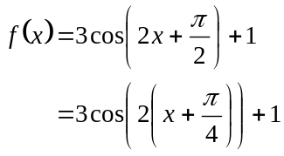
The period is 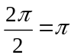 and the amplitude is 3.
The answer is B.

Question 3

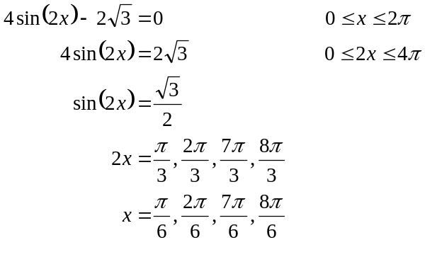
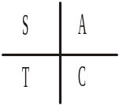
The sum is 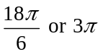.
The answer is C.

Question 4

Draw a quick tree diagram.

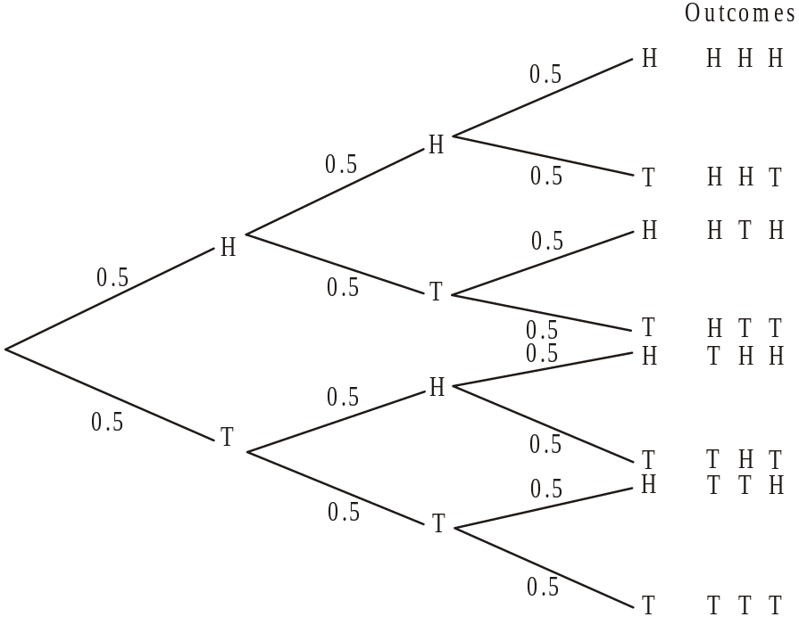

There are 8 possible outcomes,
1 of those is to get 3 heads,
3 of those are to get 2 heads,
3 of those are to get 1 head,
and 1 of those is to get 0 heads.
The answer is C.

Question 5

Sketch the graph of 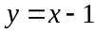.

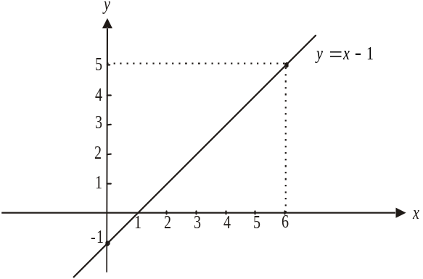

For the function f, 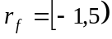.
Looking at the graph when 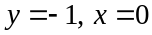. (Check 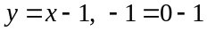).
Again looking at the graph when 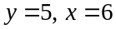. (Check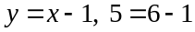).
So the domain of 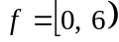
The answer is D.

Question 6

A translation of 2 units to the left changes the rule 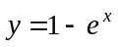to become 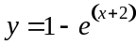.
A reflection in the y-axis changes the rule to 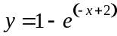
The answer is B.

Question 7

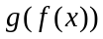 exists if 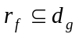.
Now 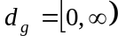.
So we require that 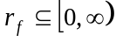.
For option A. 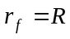.
For option B. .
For option C. .
For option D. 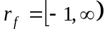.
For option E. 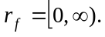
The answer is E.

Question 8
Let 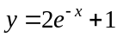
Swap x and y
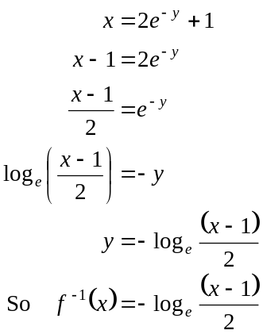
The answer is A.

Question 9

Method 1

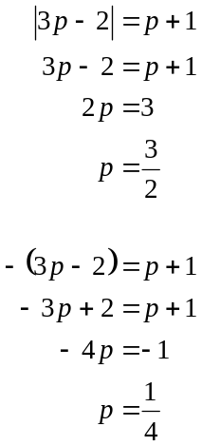
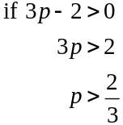
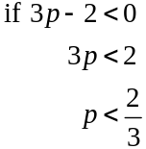

The answer is D.

Method 2

Sketch 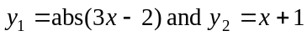.
Points of intersection occur at 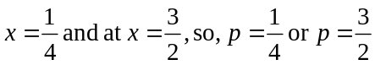.
The answer is D.

Question 10

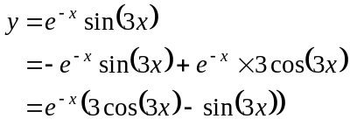
The answer is C.

Question 11

Method 1
Method 2
Sketch 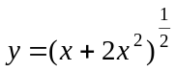.
Calculate 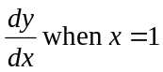.
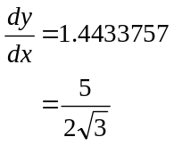

The answer is E.

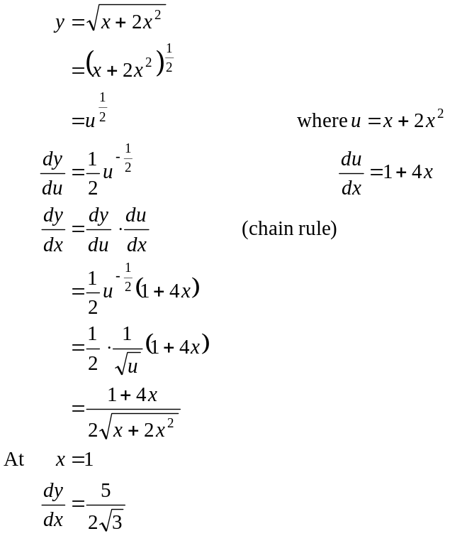
The answer is E.

Question 12

Let v equal the volume of the cylinder.
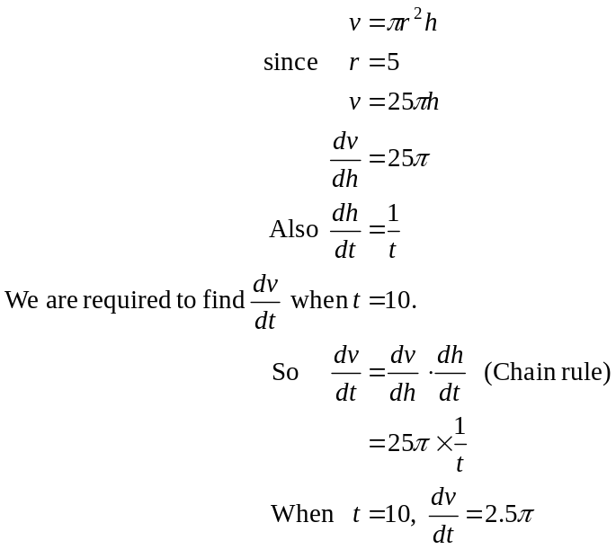
The answer is B.

Question 13

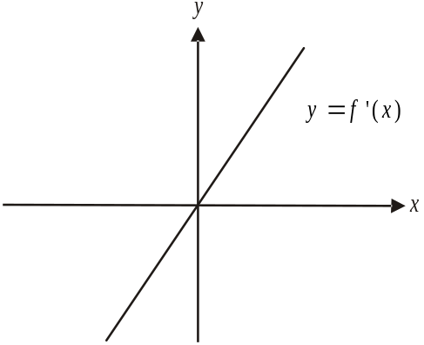
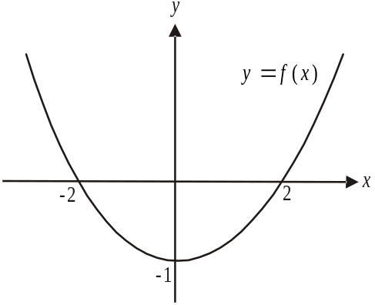

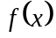 is positive for 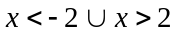.
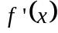 is the gradient of and is positive for .
So and are both positive for .
The answer is D.

Question 14

Let the antiderivative function of f be called g.
So 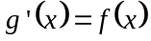.
For 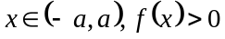 so the graph of g will have a positive gradient.
Note that for there to be a stationary point (which may be a local min/max or point of inflection) 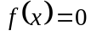. For 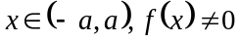.
The answer is A.

Question 15

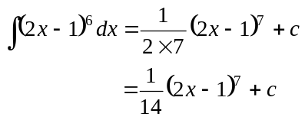
The answer is A.

Question 16

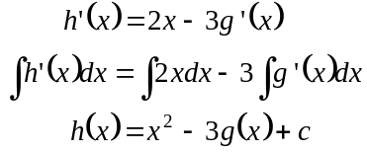
Now 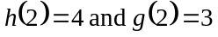
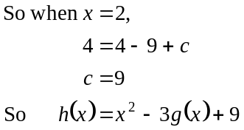
The answer is E.

Question 17

Sketch the graph.

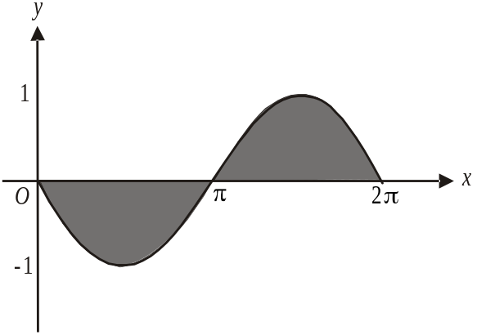

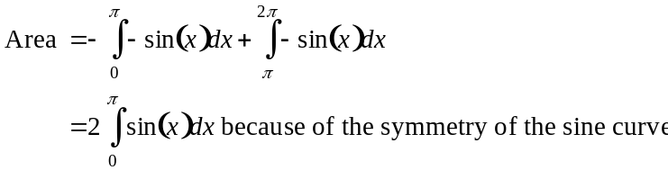
The answer is B.

Question 18

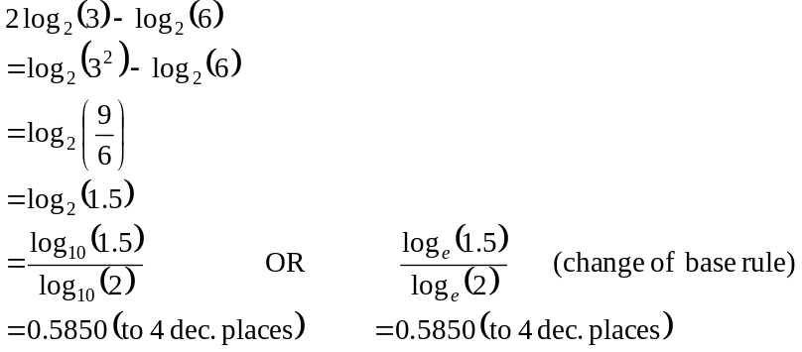
The answer is C.

Question 19
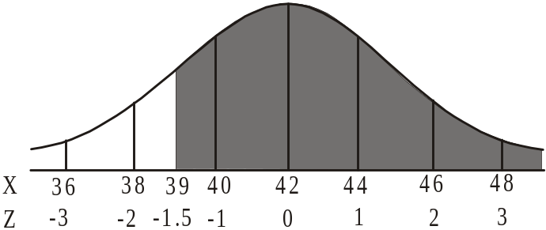

The shaded area is given by normalcdf(39, 100, 42,2) = 0.93319…
= 93% to the nearest percent
(Alternatively, normalcdf(-1.5,100,0,1) = 0.93319…)
The answer is C.

Question 20

This represents a binomial distribution because there is a fixed probability of an event happening i.e. 0.78 and there is a fixed number of “trials” i.e. 4 and we want a particular number of events to occur i.e. 3 or 4.
Method 1

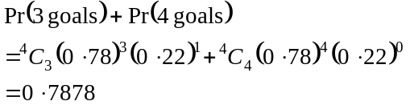

The answer is E.

Method 2

binompdf(4,0.78,3) + binompdf(4,0.78,4)
= 0.7878

The answer is E.

Question 21

The mode is the value of x for which the maximum value of f occurs.
Now, 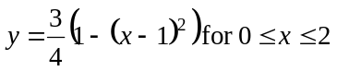, describes the graph of an inverted parabola with a maximum turning point at 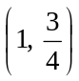.
So the maximum value of f is and it occurs at .
The mode (that is the most popular value) is 1.
The answer is D.

Question 22

The graph of 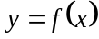 could be
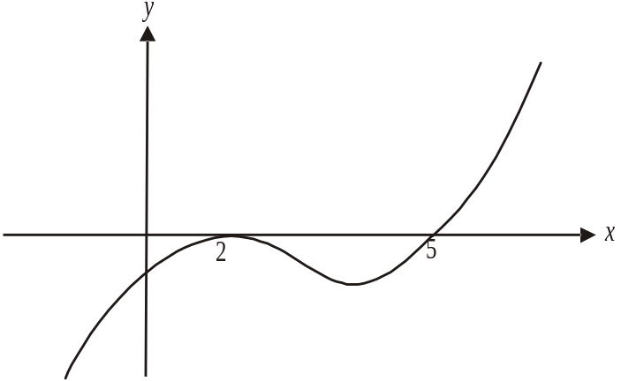

or

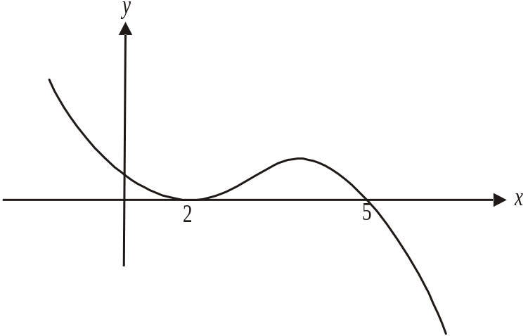

Both of these graphs produce the graph of 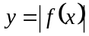.
The equation of the first could be 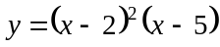. This is option E.
The equation of the second could be 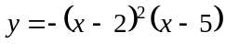. This is not offered.
The answer is E.

SECTION 2

Question 1

- 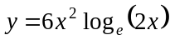
x-intercept occurs when 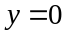
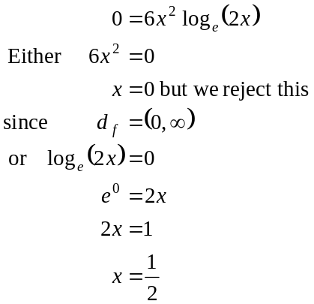
The x-intercept occurs at 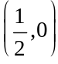 as required
(1 mark)

- The function 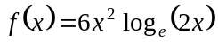 is only defined for values of x such that ; that is, for because 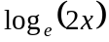 is only defined for these values.
(1 mark)

- Use a graphics calculator to locate the turning point. It is the point 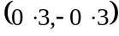 where each coordinate is correct to one decimal place.
(1 mark)

- From part c. the range is 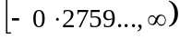 or 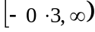 correct to one decimal place.
(1 mark)

- i. The function f does not have an inverse function because it is not a function.
(1 mark)

    - The function g must be a function since 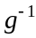 exists.
The maximal domain of g is therefore 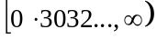 where the value of a is the x-coordinate of the turning point of the curve. The answer is where a is correct to one decimal place.
(1 mark)

- i.
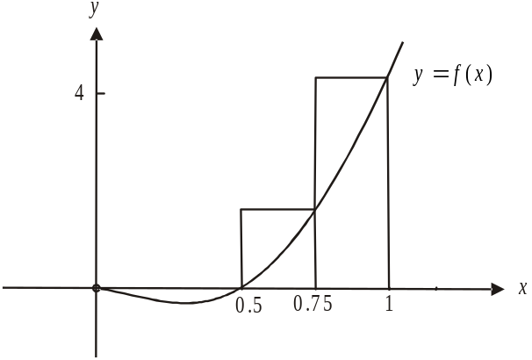

(1 mark)

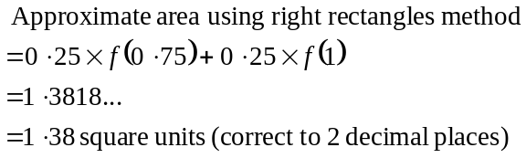 (1 mark)

  - Since the right rectangles extend above the function f the approximation will be greater than the exact area.
(1 mark)
g. i.
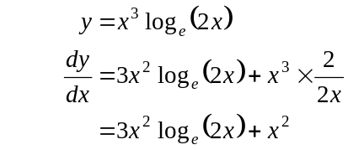
(product rule)
(1 mark)
So 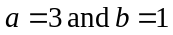
(1 mark)
- Hence means use what you have already found.
From part i., we found that 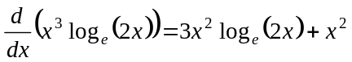
If we antidifferentiate each term on both sides, we obtain
.
Rearranging, we obtain
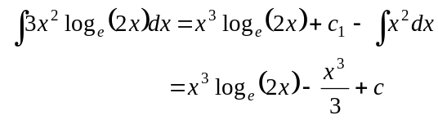
(1 mark)
(Note that c = the sum of and the constant that arose from 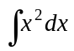.)
So 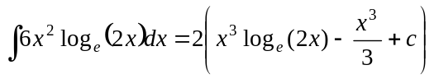
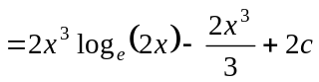

Now the exact area
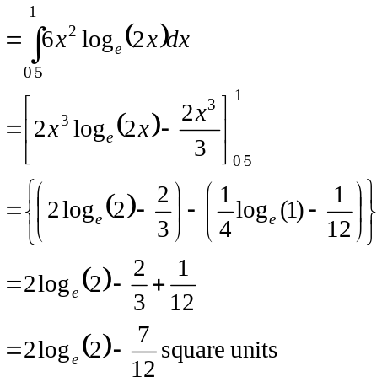
(1 mark)
(1 mark)
(1 mark)
(Note – if you have time, check your answer using a calculator:
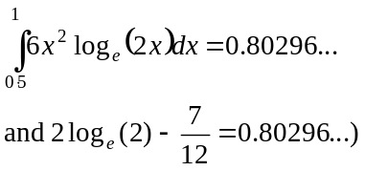

Total 15 marks

Question 2

- i. The probability that Sealord’s provides the seafood on Thursday, Friday and Saturday given that it supplied it on Wednesday is .
(1 mark)

- Draw a tree diagram to see all the possible outcomes.
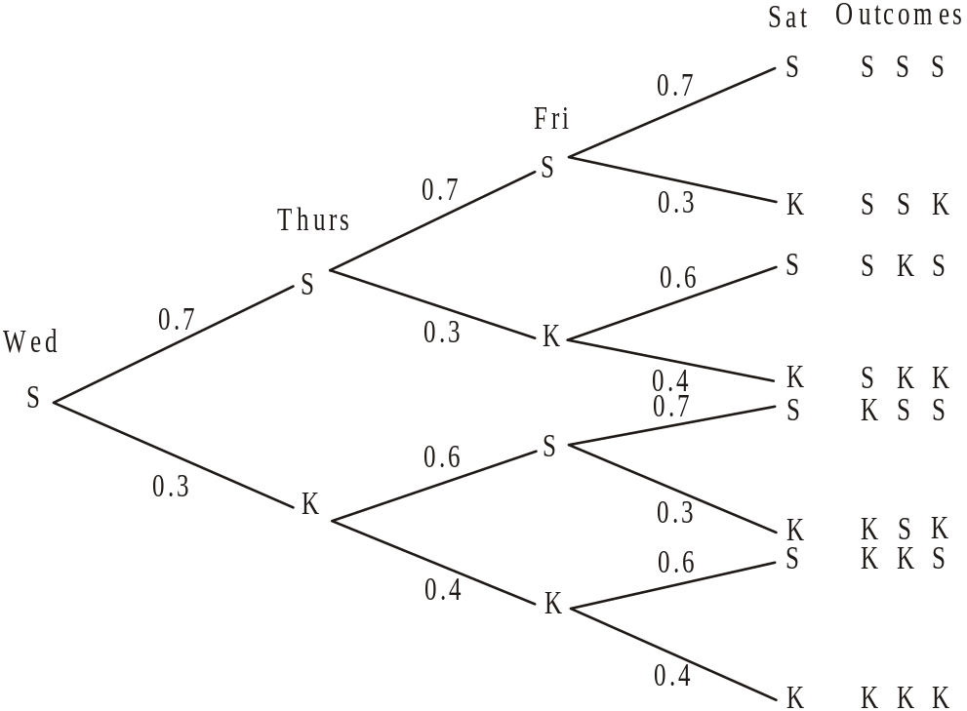

(1 mark)
Looking at the possible outcomes the probability that Sealord’s supplies on at least two of the next three nights
(1 mark)
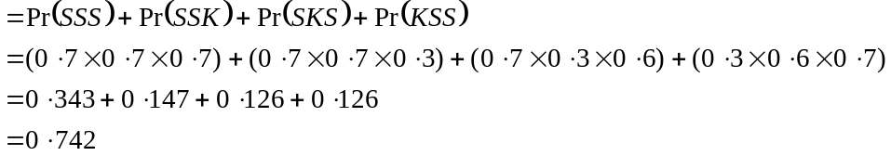
(1 mark)
- From the tree diagram, the probability that the first time Kingfisher supplies the restaurant is on Saturday or on Sunday.
(1 mark)
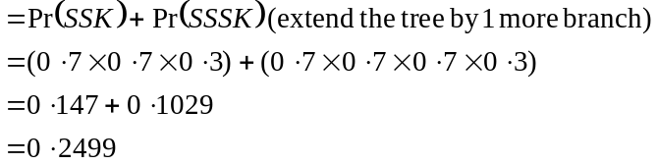
(1 mark)
- Pr(Marco spends more than 5 hours in the kitchen on a particular night)
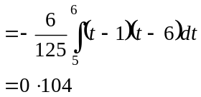
(1 mark)
(1 mark)

- This is a binomial distribution with 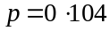 (from part b.), .
Method 1
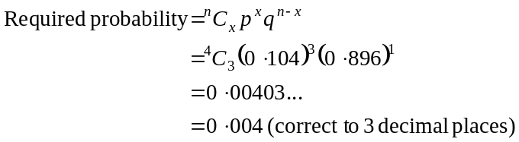
Method 2
Using a calculator, binompdf(4,0.104,3) = 0.004 (correct to 3 decimal places)

(1 mark) for correct answer
(1 mark) for recognition that it was a binomial distribution

- Method 1
Sketching the graph.

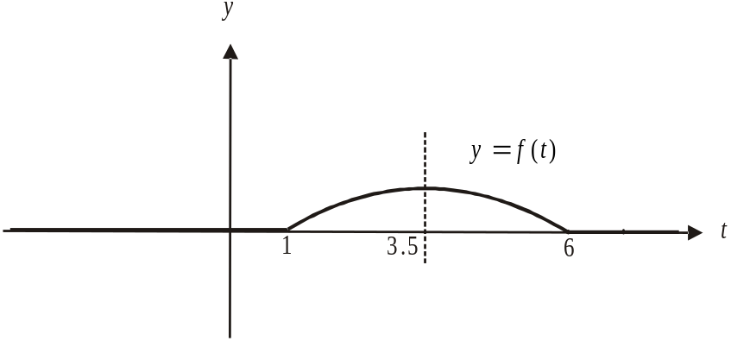

(1 mark)
We have an inverted parabola with its axis of symmetry located at .
So the median time spent in the kitchen on a night by Marco is 3.5 hours since the area under the graph for is equal to the area under the graph for .
(1 mark)

Method 2
Let m be the median.
We require that
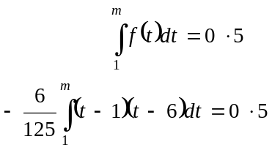
(1 mark)
Use your calculator and a trial and error method to find the upper limit m.
It is 3.5.
(1 mark)

Method 3
Let m be the median.
We require that
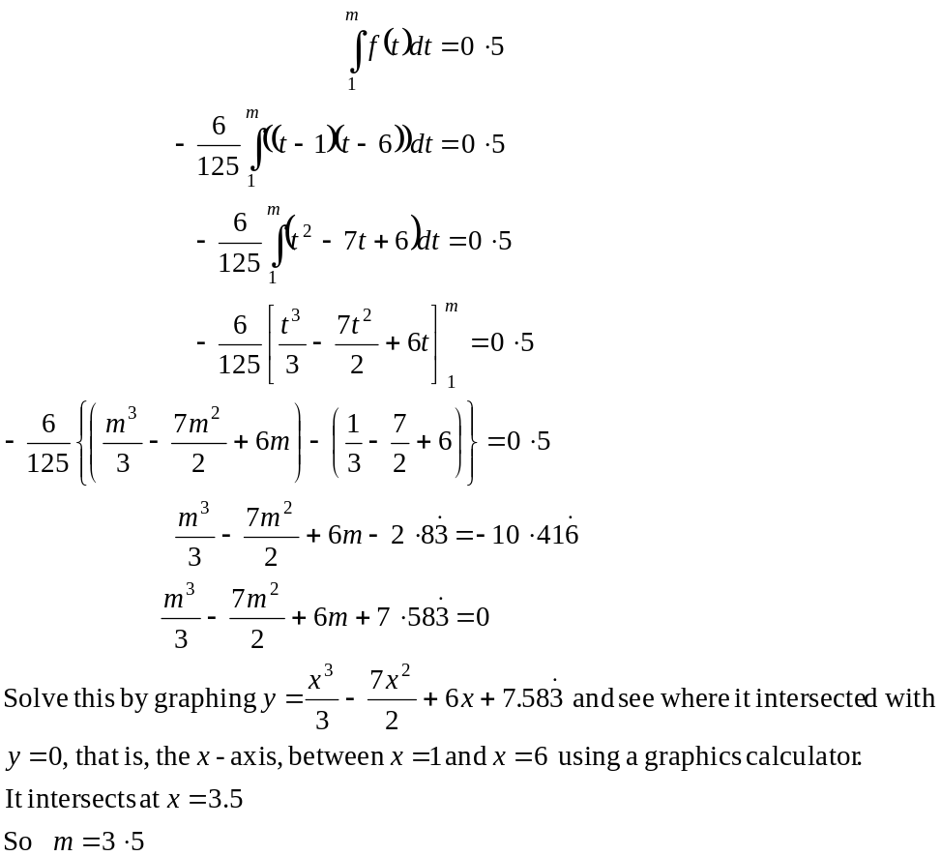
(1 mark)
(1 mark)

Total 12 marks

Question 3

- i. At point A, .
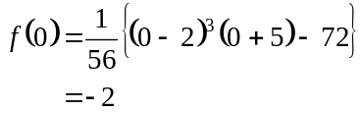
A is the point 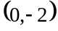.
(1 mark)
- At point C, .
Use a graphics calculator to solve 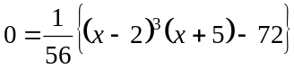.
The answers are .
C is the point 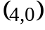.
(1 mark)
- 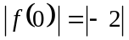 from part a.i.
(1 mark)
c. Method 1 – expanding then differentiating

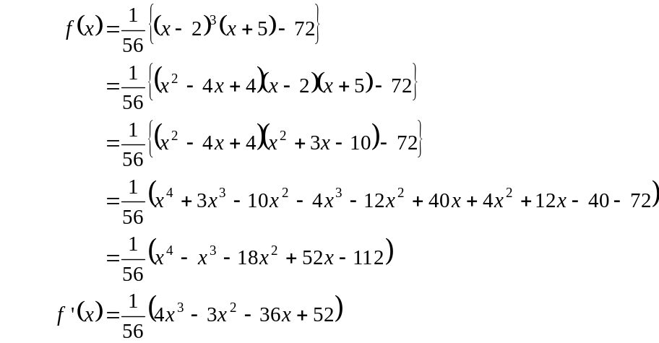
(1 mark)
(1 mark)

Method 2 – using the product rule

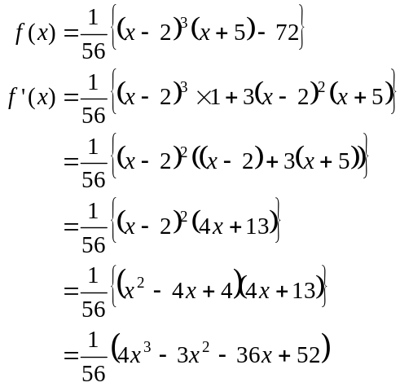
(1 mark)
(1 mark)

- i. At point B, 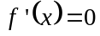.

Method 1 – following on from Method 1 in part c.
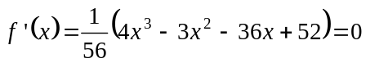
Use a graphics calculator to solve this. is a solution that corresponds to B’s position.

Method 2 – following on from Method 2 in part c.
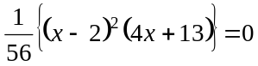
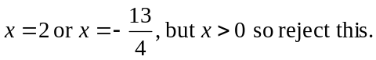

Now,
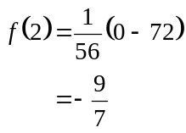
B is the point 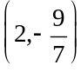

(1 mark)

  - B is a stationary point because at B,
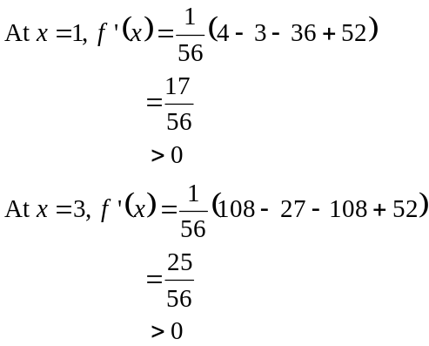
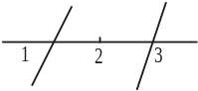
Since the gradient to either side of point B is positive but at point B the gradient is zero, there is a stationary point of inflection at B.
(1 mark)
(1 mark) for first derivative test

- Area of garden bed
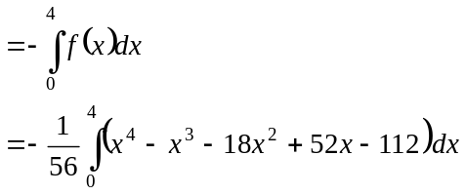
(negative because the area falls below the x-axis)
(1 mark) – correct terminals
(1 mark) – correct function

- i. The Fulton’s garden border is described by 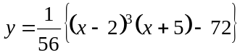 so the George’s garden border is described by 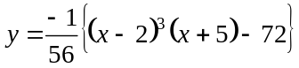.
(1 mark)

  - Since C is the point (from part a. ii.) 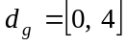.
(1 mark)
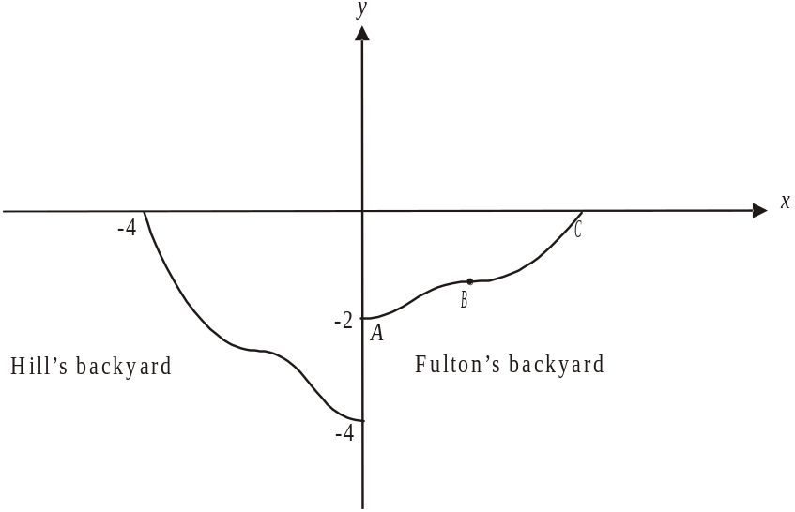
- i.

(1 mark)
  - The rule for the garden border in Fulton’s garden is given by .
When this function is reflected in the y-axis the rule becomes 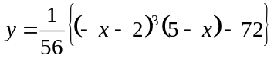
When this function is then dilated by a factor of 2 from the x-axis the rule becomes
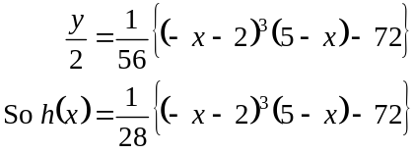
(1 mark)

- i. The function 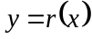 is the inverse function of the function and vice-versa.
(1 mark)

- The coordinates of the point 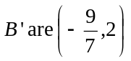 because the coordinates of B are from part d.i.
(1 mark)

Total 16 marks
Question 4

- Since 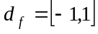 and since the point A is at the right hand endpoint of the graph, .
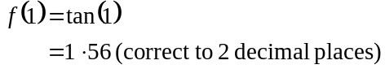
A is the point 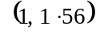
(1 mark)

- The function f is not defined for 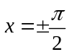, since an asymptote exists on the graph of 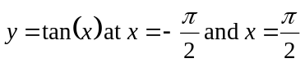.
Since 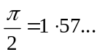, this would be within 2km in the directions east and west of the intersection.
(1 mark)

- 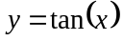
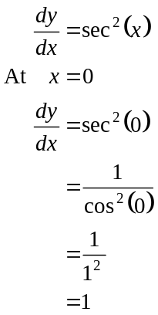
(1 mark)

So at the point of intersection (i.e. 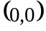), the gradient of the function 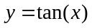 is 1 and so the rail line makes an angle of 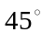 or 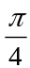 with the road heading north (and of course with the road heading east).
(1 mark)

- At point B,
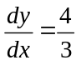
Since point B lies on the main rail line, we have
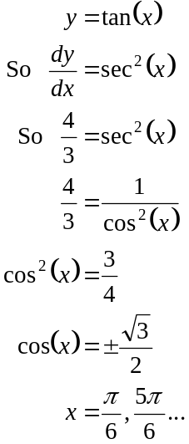
(1 mark)
(1 mark)
Since 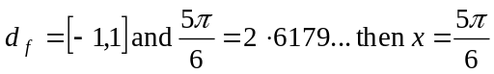 is outside the domain.
(1 mark)
The value of x is 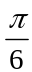.
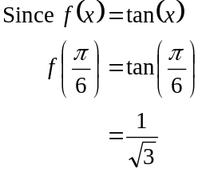
So B is the point 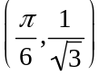. (1 mark)
- The gradient of the shunting line is and it passes through .
The equation of the shunting line is 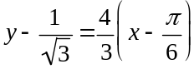. (1 mark)
The road running in the east-west direction is represented by the x-axis along which .
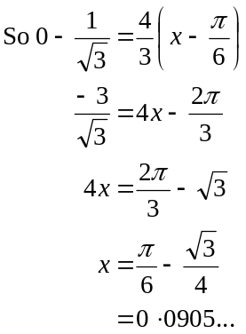
(1 mark)
Since , the point of intersection occurs on the east side of the dangerous intersection. (1 mark)
f. i. The curves with equations 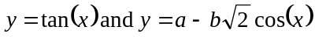 meet smoothly
at point C where 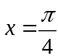.
This means firstly that at
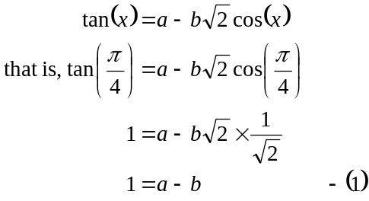
(1 mark)
Secondly, this means that if
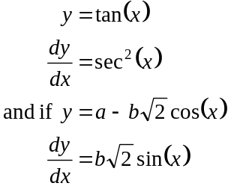
At , the gradients are equal (1 mark)
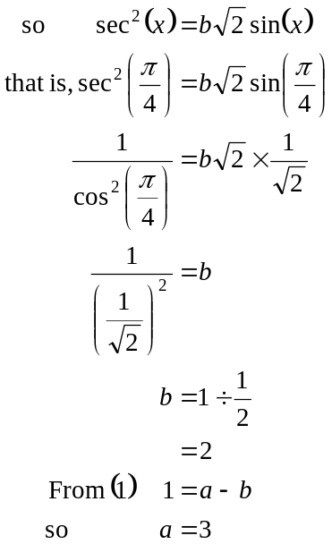
Have shown.
(1 mark)
- We are looking for the y-intercept of the graph of 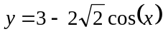.
When ,
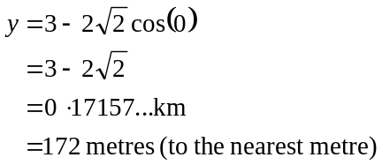
(1 mark)
Total 15 marks

